DevSecOps

Objective
To configure and execute a DevSecOps pipeline in Jenkins using a Freestyle Project and a Declarative Pipeline for the Spring PetClinic application.
Purpose
To automate source code checkout, application build, testing, and security scanning to identify potential vulnerabilities before delivering the application.
Source code: https://github.com/betawins/spring-petclinic.git
DevSecOps pipeline flow
1. Source Code
GitHub checkout
2. Build
Maven compile and package
3. Security Scan
SonarQube code analysis
4. Dependency Scan
OWASP Dependency-Check
5. Test and Archive
Run tests and save the JAR artifact
This is a learning pipeline. A security scan only helps when its reports are reviewed and its failure conditions are configured. SonarQube and OWASP Dependency-Check require their respective tools and integrations to be configured in Jenkins.

- Setup DevSecOps pipeline using freestyle project.
Source Code: https://github.com/betawins/spring-petclinic.git

Step 1: Install Jenkins plugins
- Open Jenkins.
- Go to Manage Jenkins → Plugins → Available plugins.
- Install:
  - Git
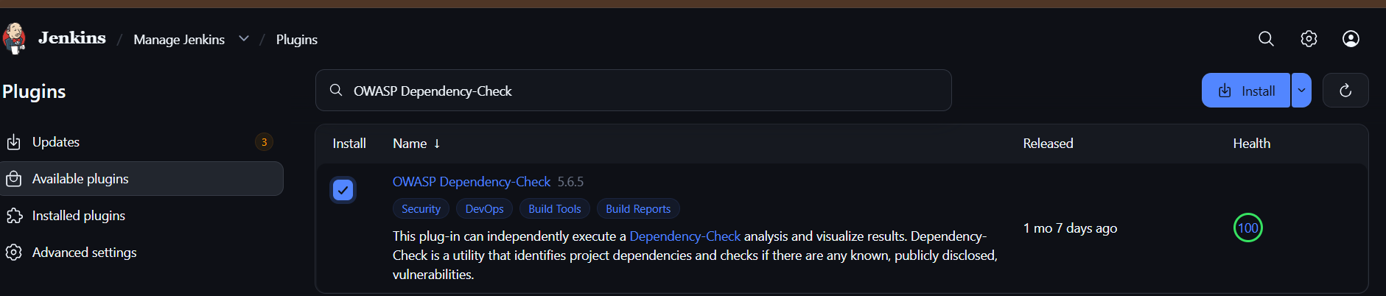
  - OWASP Dependency-Check

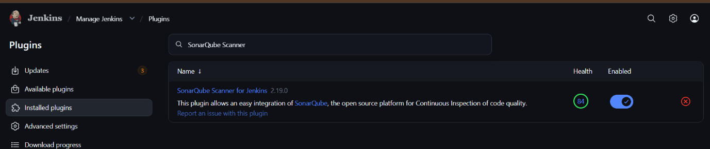
  - SonarQube Scanner

Step 2: Configure Java and Maven
- Go to Manage Jenkins → Tools.
- Configure the JDK if required.
- Configure Maven.
- Save the settings.
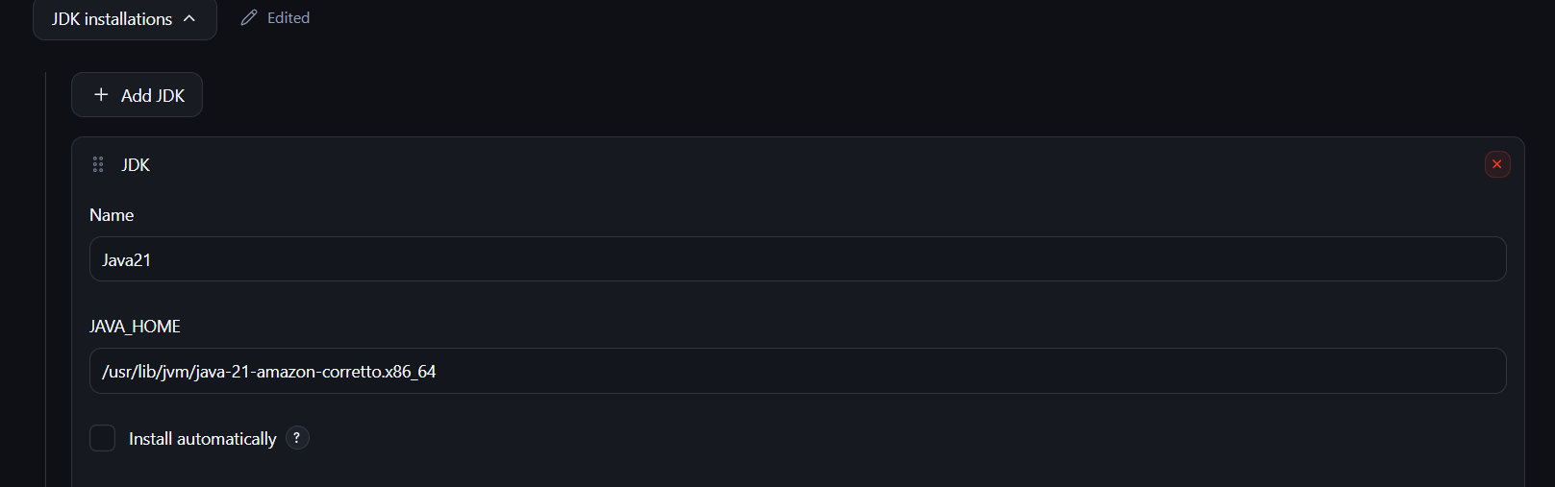
Ensure Java and Maven are installed and available on the Jenkins agent.
Step 3: Create a Freestyle project
- Click New Item.
- Enter the name:
petclinic-devsecops-freestyle
- Select Freestyle project.
- Click OK.
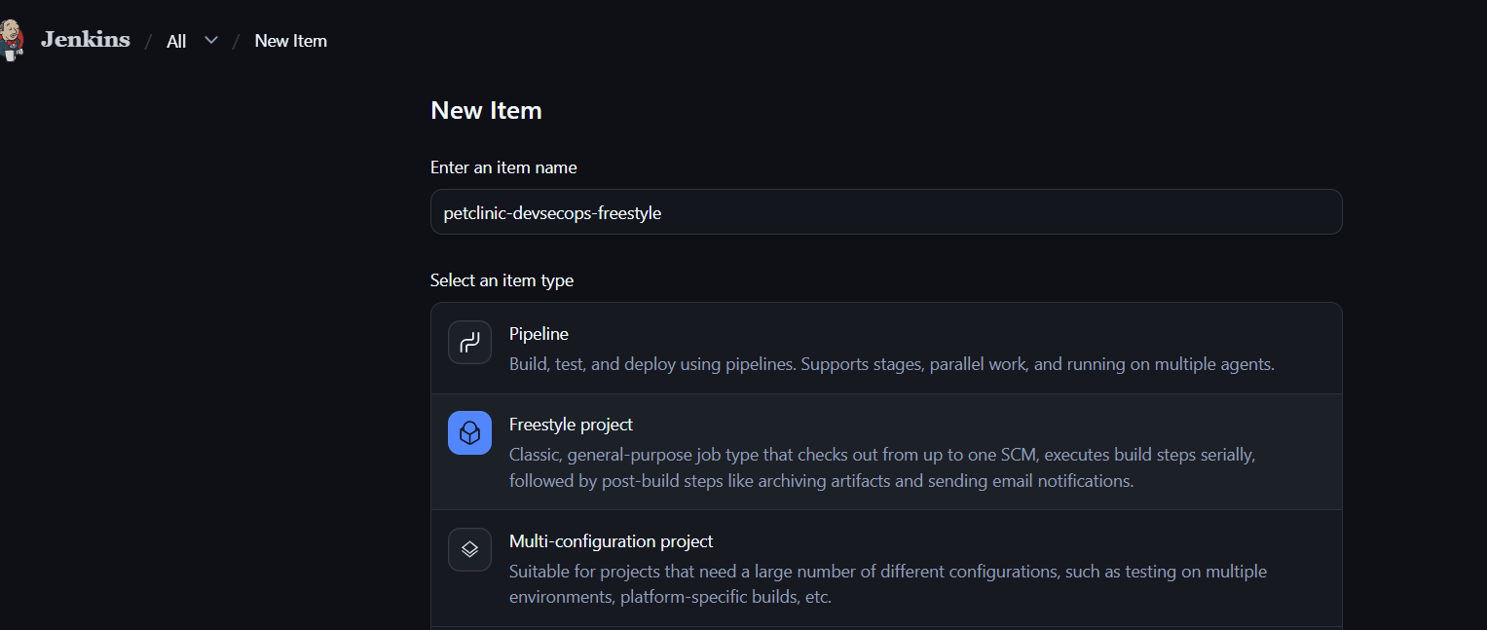
Step 4: Configure source code
Under Source Code Management:
- Select Git.
- Enter the repository URL:
https://github.com/betawins/spring-petclinic.git
- Set the branch to */master, if main is the repository's default branch.
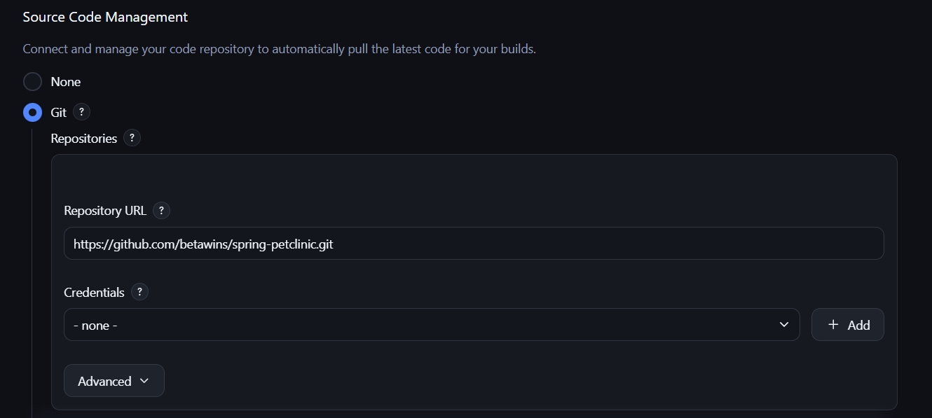
Step 5: Configure the build
Under Build Steps:
- Click Add build step.
- Select Invoke top-level Maven targets.
- Enter the goals:
clean verify
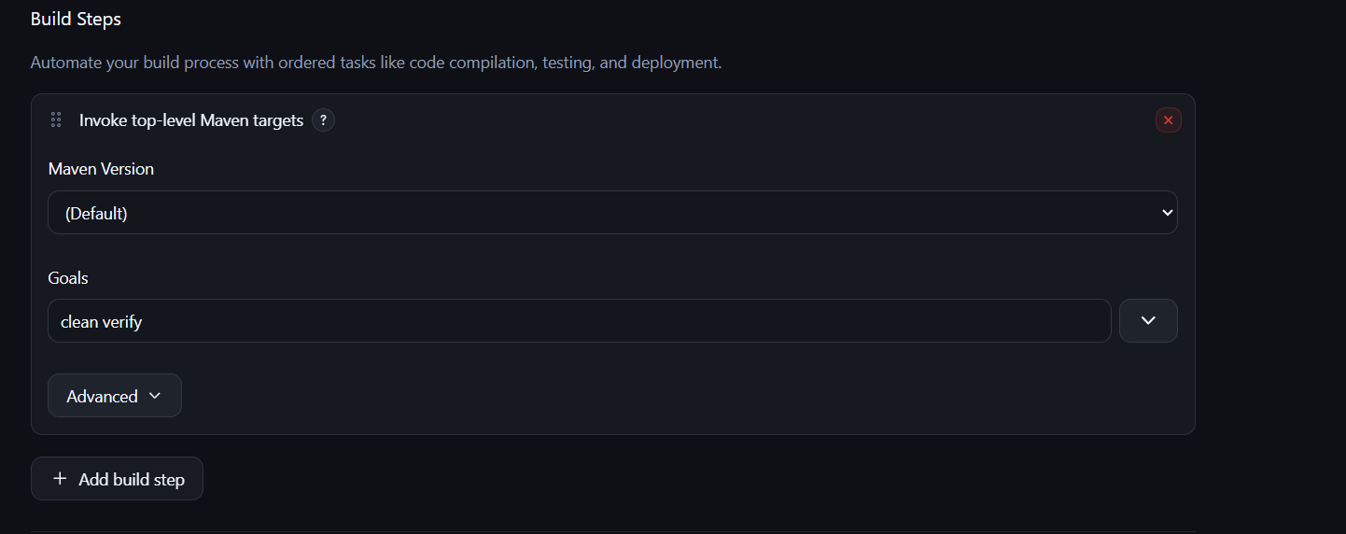
This compiles the application, runs its configured tests, and verifies the build.

Step 6: Add dependency security scanning
Add another build step using Execute shell:
mvn org.owasp:dependency-check-maven:check
This checks project dependencies for known vulnerabilities. Ensure Dependency-Check is configured and its Maven goal is available.
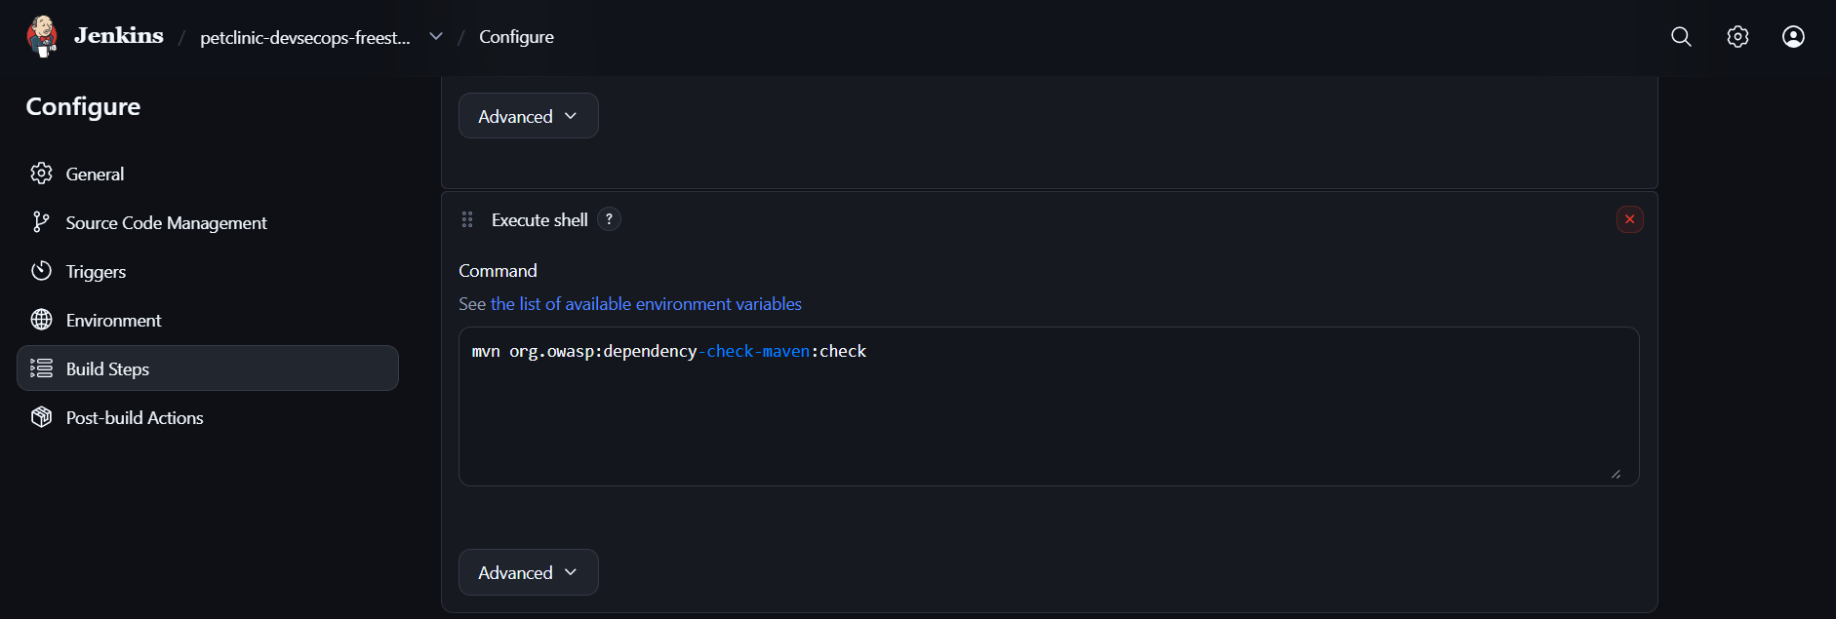
Step 7: Archive the artifact
Under Post-build Actions, select Archive the artifacts.
Enter:
**/target/*.jar
Click Save.
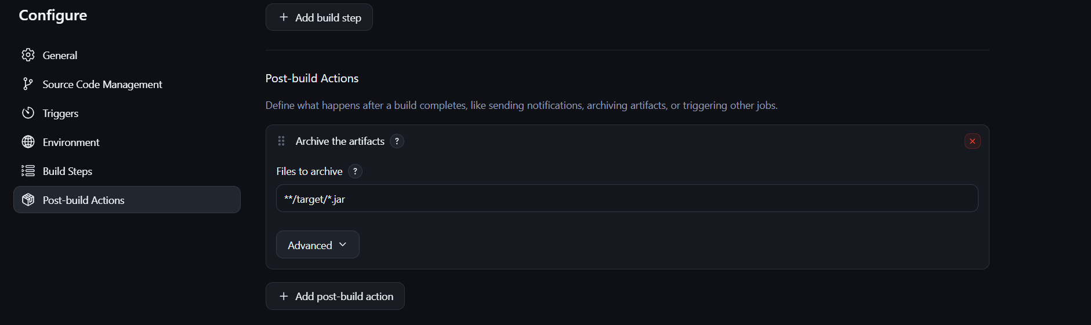

Step 8: Execute the job
- Click Build Now.
- Open the build number.
- Click Console Output.
- Verify that the build and security scan complete successfully.
Expected result: Jenkins builds the Spring PetClinic application, executes tests, scans dependencies, and archives matching JAR files.
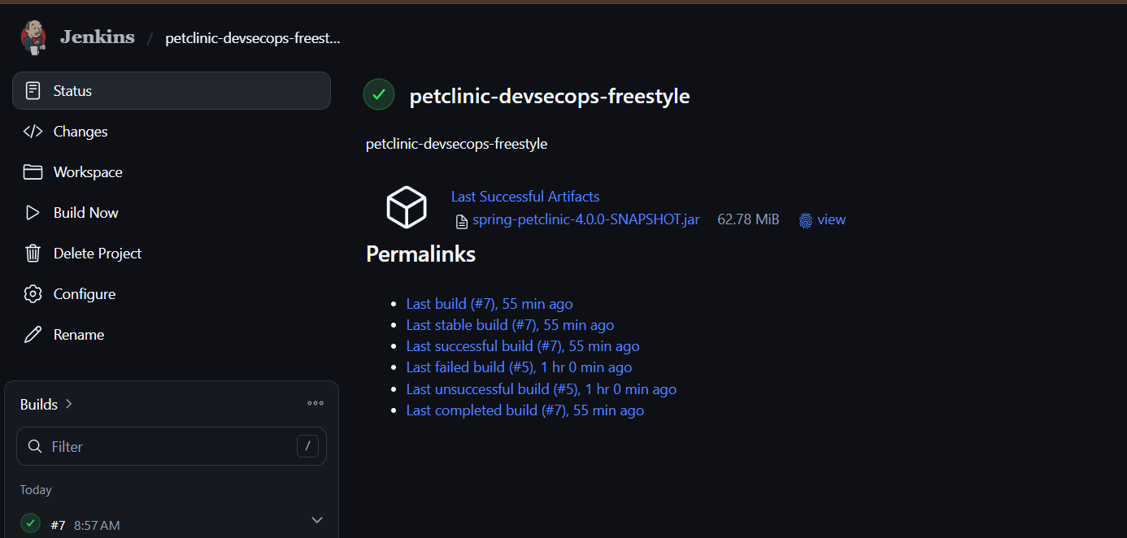

2) Setup SevSecOps pipeline using Declarative pipeline.
Source Code: https://github.com/betawins/spring-petclinic.git
Part 2: DevSecOps using a Declarative Pipeline
Step 1: Create a Pipeline job
- Click New Item.
- Enter:
petclinic-devsecops-pipeline
- Select Pipeline.
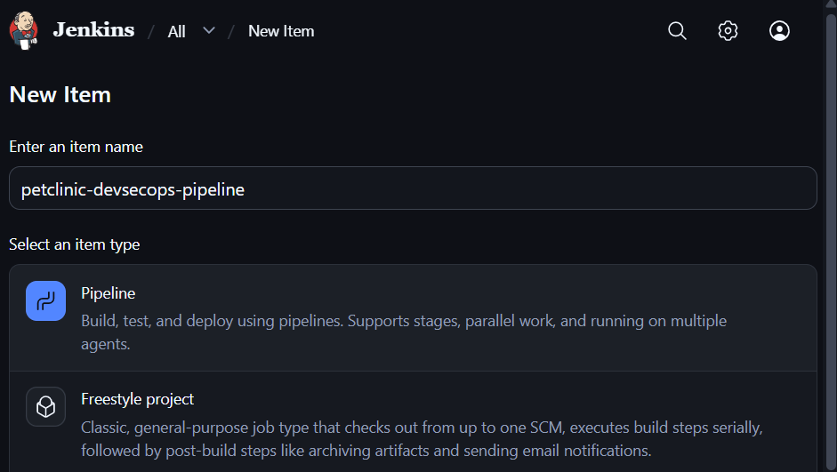
- Click OK.

Step 2: Configure the Pipeline
- Scroll to the Pipeline section.
- Set Definition to Pipeline script.
- Paste the following code.

pipeline {
agent any

stages {
stage('Checkout') {
steps {
git branch: 'main',
url: 'https://github.com/betawins/spring-petclinic.git'
}
}

stage('Build') {
steps {
sh 'mvn clean package -DskipTests'
}
}

stage('Test') {
steps {
sh 'mvn test'
}
}

stage('Dependency Scan') {
steps {
sh 'mvn org.owasp:dependency-check-maven:check'
}
}

stage('Archive Artifact') {
steps {
archiveArtifacts artifacts: '**/target/*.jar',
fingerprint: true
}
}
}

post {
success {
echo 'Pipeline completed successfully'
}
failure {
echo 'Pipeline failed. Check Console Output'
}
}
} 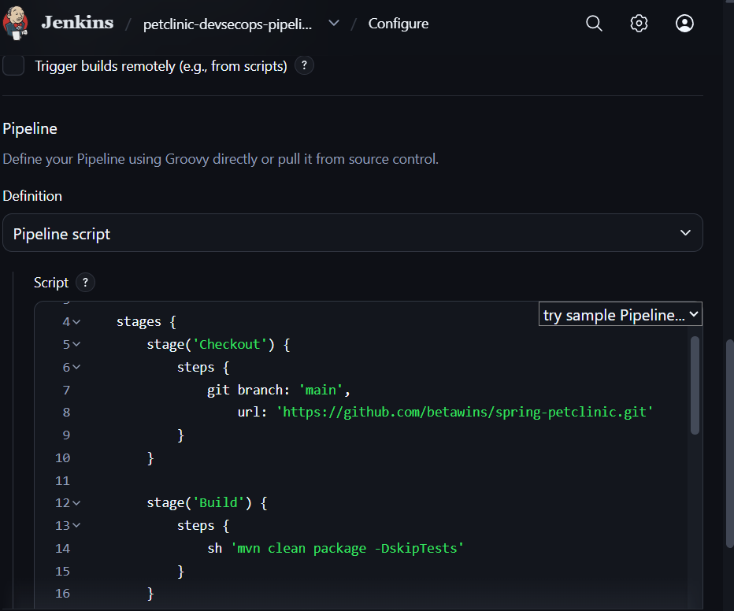
Note: Change main if the repository uses another default branch. This example assumes Maven, Java, and Dependency-Check are configured. The dependency scan can fail if vulnerability data access or scanner configuration is unavailable.

Step 3: Save and execute
- Click Save.
- Click Build Now.
- Open the build.
- Select Console Output.
- Verify the stages and investigate any errors.
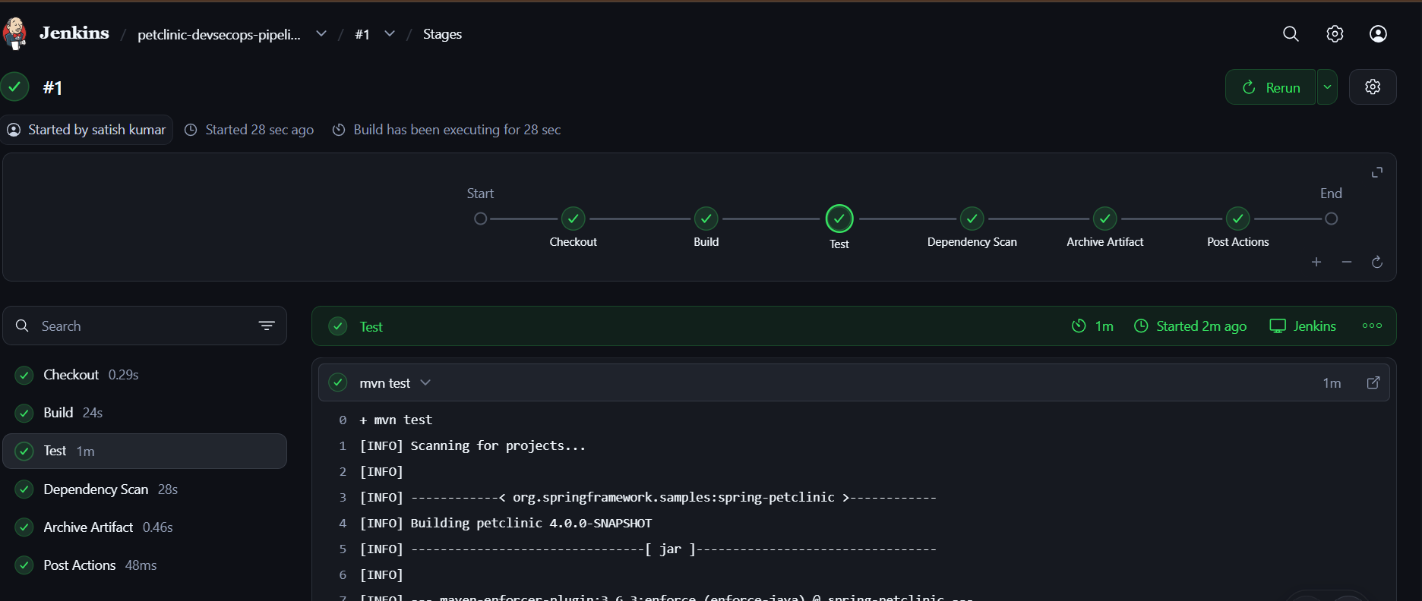
Expected result: Jenkins automatically checks out the source code, builds the application, runs tests, scans dependencies, and archives the build artifact.
Result
The DevSecOps pipeline is configured using both Jenkins Freestyle and Declarative Pipeline approaches. Both approaches automate application build and testing and include a dependency vulnerability scan.
Important: To make this a complete DevSecOps pipeline with static code analysis, configure SonarQube and add a SonarQube analysis stage. Installing the plugin alone does not perform a scan.

